“Rui Castro is a small shop dedicated to the creation of chocolate experiences”

This case study shows the transformation of this start-up business model thanks to the CircularStart training materials.
Sector/Activity: food (selling chocolat experiences)
Circular Business Model Category: circular base service
Circular Business Model Strategy(ies): TopHill/downhill
Circular Start-up type: circular base service

STARTING POINT:
Mission: Presenting the “Portuguese language” market with the “art” of recreating gustatory proposals in the use of cocoa, surpassing the expectations of customers and other partners.
Vision: to be a company in the world of chocolate, sustained and recognized, generating unique and eternal experiences
Values: Proximity and empathy, creativity and innovation, respect for culture, passion and constant reinvention
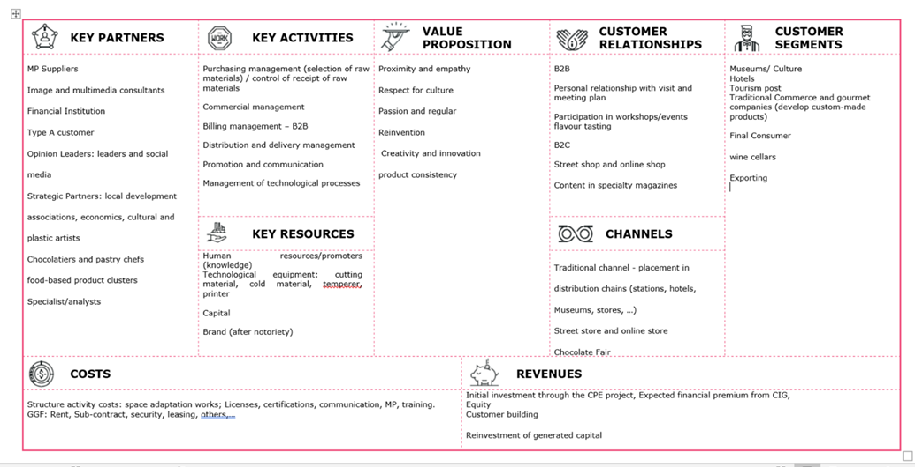
Initial circularity profile – Results from the application of the Assessment Tool

FOLLOWED LEARNING PATH:
Units | IDEATION | INTEGRATION | VALIDATION | IMPLEMENTATION
Unit 1 | X |  | X | X
Unit 2 | X | X | X | X
Unit 3 | X |  | X | X
Unit 4 | X | X |  | X
Unit 5 | X | X
Unit 6 | X
Unit 7 | X
Unit 8 | X
Unit 9 | X

FINAL CIRCULAR BUSINESS MODEL:
Mission: To present the “Portuguese language” market with the “art” of recreating gustatory proposals, sustainable in the use of cocoa, surpassing the expectations of customers and other partners.

Vision: In 2023, to be a company in the world of chocolate, sustainable and recognized, generating unique and eternal experiences.
Values:
Proximity and Empathy
Criativity and innovation Respect for Culture and Local Communities
Passion and Constant Reinvention
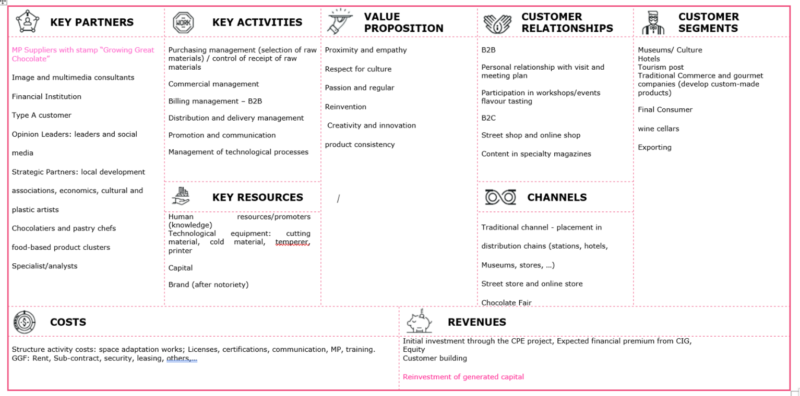

WHICH ELEMENTS/CHARACTERISTICS OF THE BUSINESS IDEA/MODEL WHERE IMPROVED THANKS TO THE CIRCULAR-START MATERIALS?
- Vision: Being a sustainable chocolat business

- Strategic Orientation: Respect for the “origins” of Cocoa;
Orientation to Traditions;
Guidance for Portuguese Communities

Resulting circularity profile – Results from the application of the Assessment Tool

NEXT STEPS
WHAT | WHEN | HOW  (People, Resources needed) | POSSIBLE DIFFICULTIES?
Reclying packing | now | Patterns, suppliers | Some difficulties to found a pack really sustainable
Fair trade |  | suppliers | The consumer could find some products less expensive

KEY MESSAGES
- “Respect for the origin of cocoa”
- “Fair trade”
- “Reusable packing “

